 Q1.Write Terraform code to provision a basic Amazon Linux 2 EC2 instance with the instance type t2.micro.

Main.tf

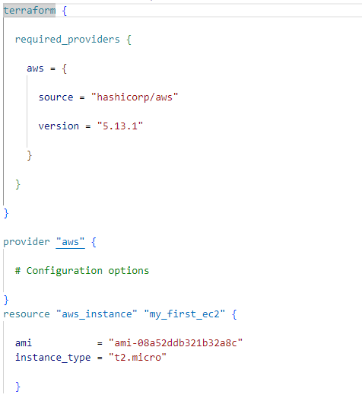

Output

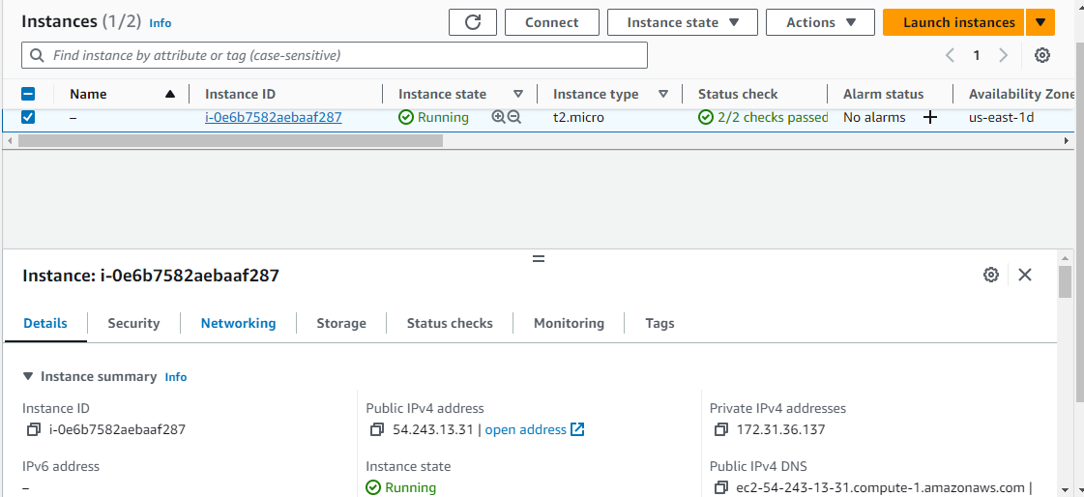

# **Q2.  Instance Tagging:**      Extend the previous Terraform code to add tags to the new EC2 instance.  Tags should include "Name" with the value "WebServer" and "Environment" with the value "Production".

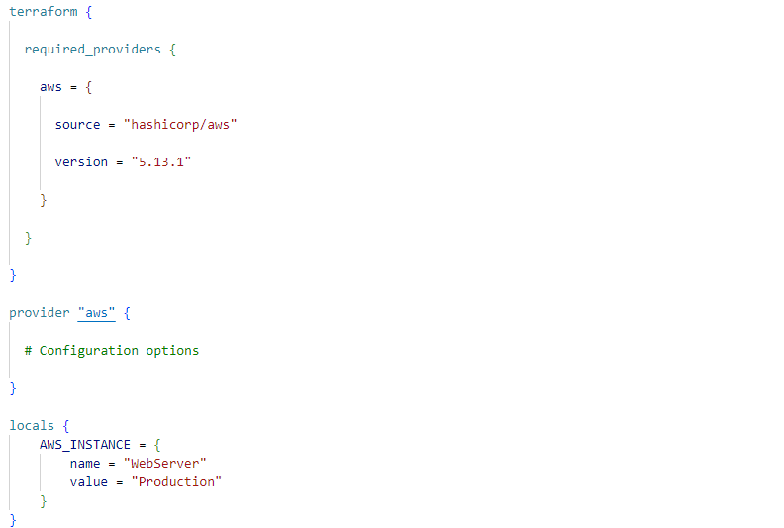

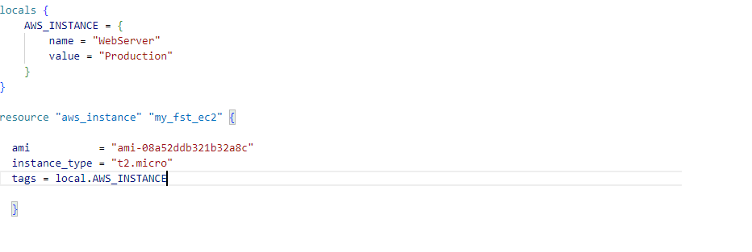

Output

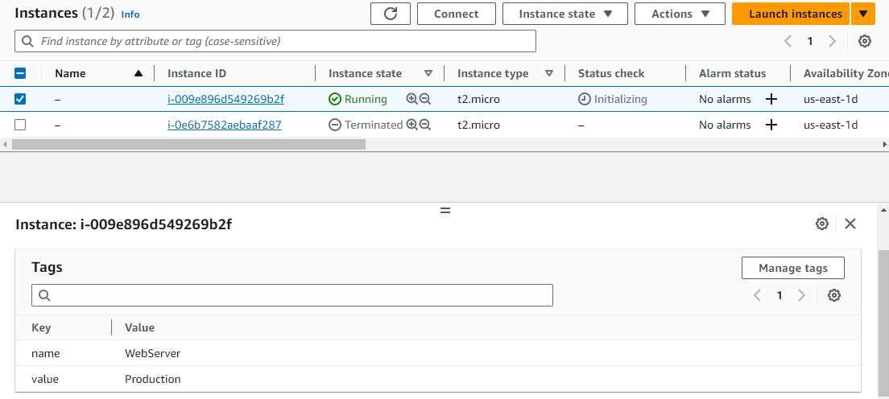

# **3.  Security Group Creation:**      Create a security group using Terraform that allows incoming HTTP (port 80) and SSH (port 22) traffic.

# Attach this security group to the new EC2 instance.

Providers.tf

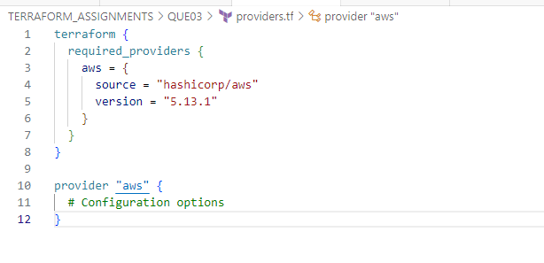

Variables.tf

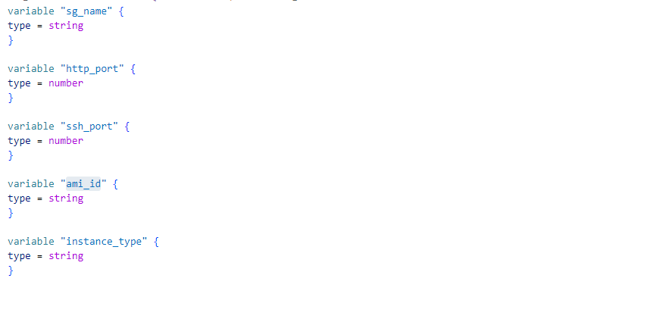

terraform.tfvars

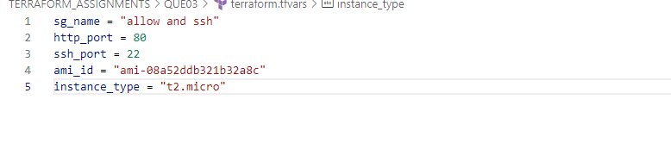

Main.tf

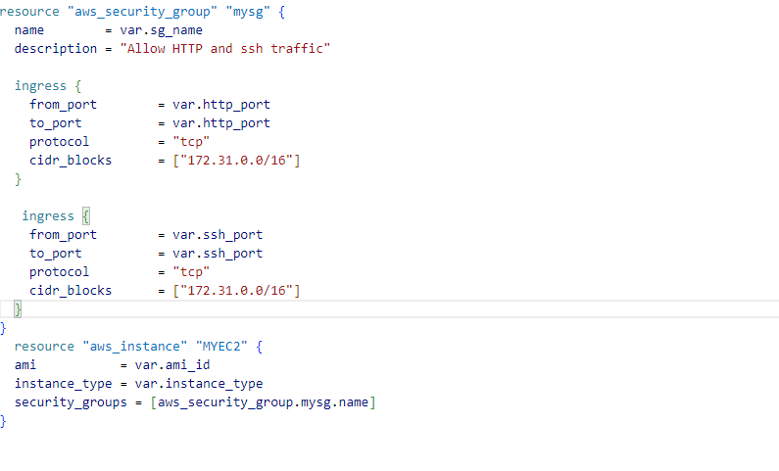

Output

After Terraform Apply

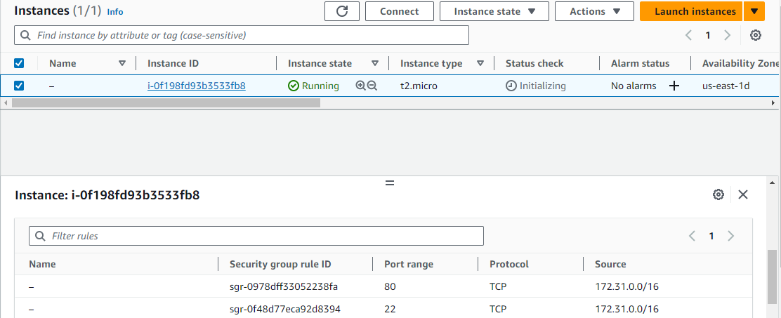

1. **Key Pair Management:**  
        Incorporate Terraform code to create an AWS key pair named "my-key-pair". Associate this key pair with the new EC2 instance.

Providers.tf

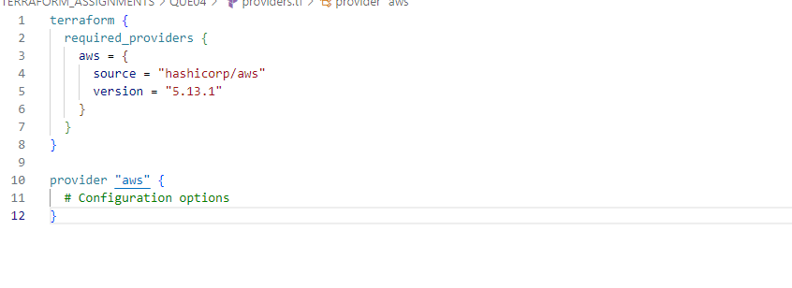

Variables.tf

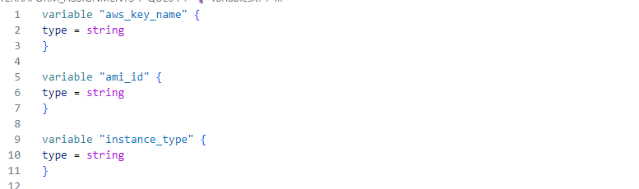

Terraform.tfvars

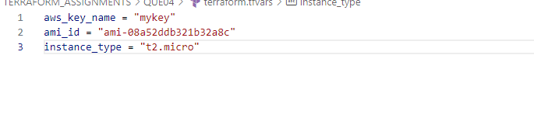

Main.tf

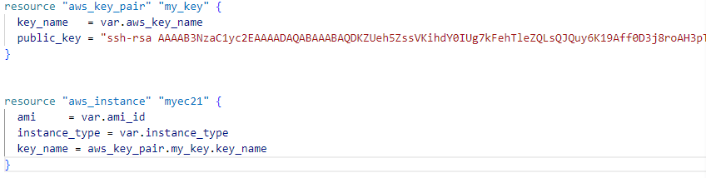

Output

After terraform apply

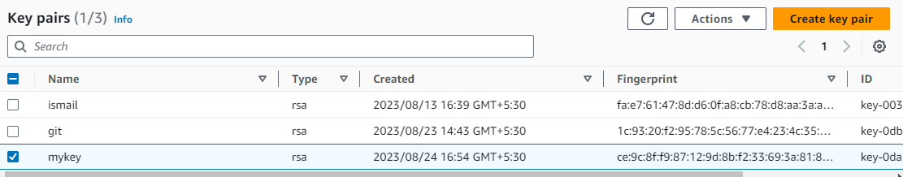

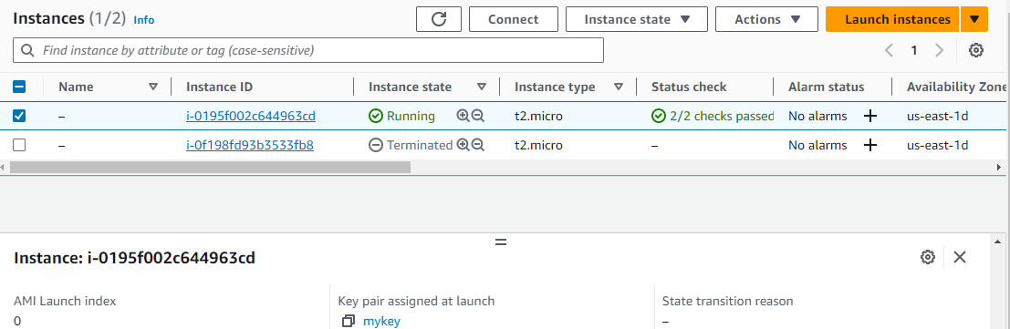

1. **Instance Count:**  
        Modify the existing code to provision 3 Ec2 instances of the same type and associate new key pair with those instances.

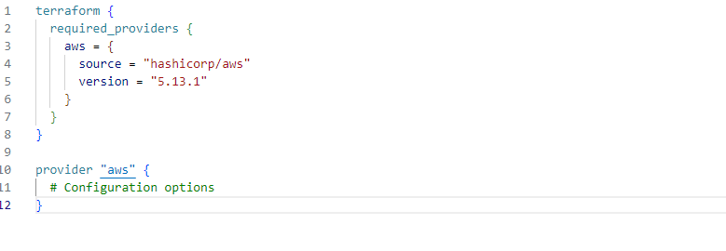

Variables.tf

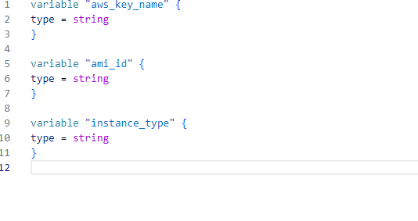

Terraform.tfvars’

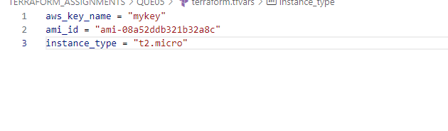

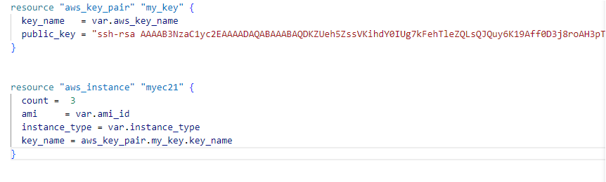

Output after terraform apply

